Harika Jupaka
2403A51L31
B-52

Lab 1.5: AI-Assisted Coding using GitHub Copilot

Task 0: Environment Setup
Steps:
- Install Visual Studio Code
- Open VS Code → Extensions
- Search GitHub Copilot
- Click Install
- Sign in with GitHub account
- Enable Copilot suggestions
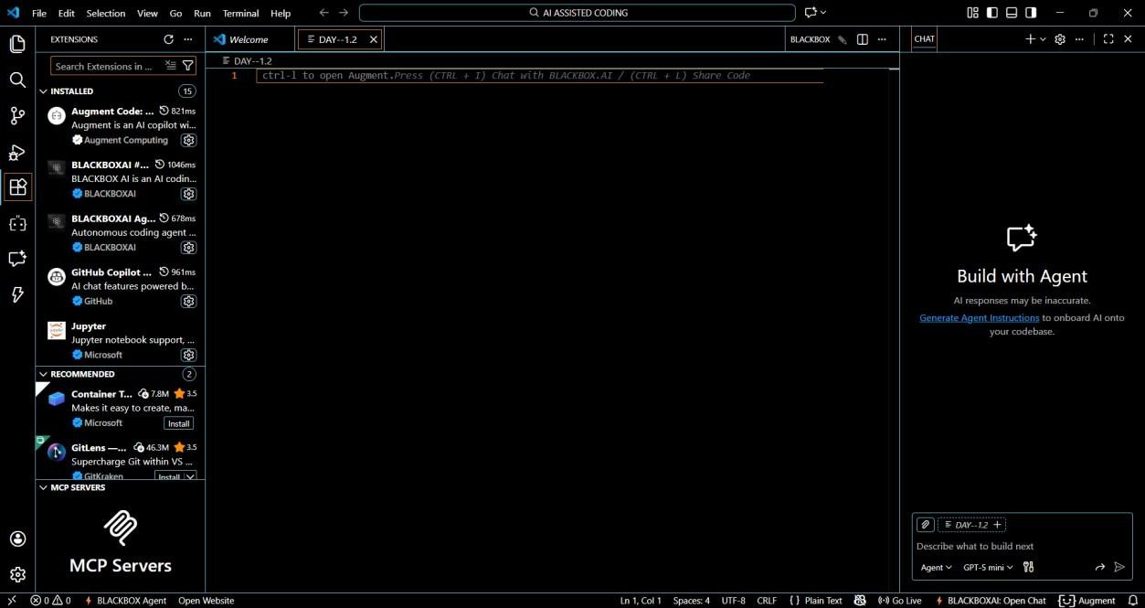
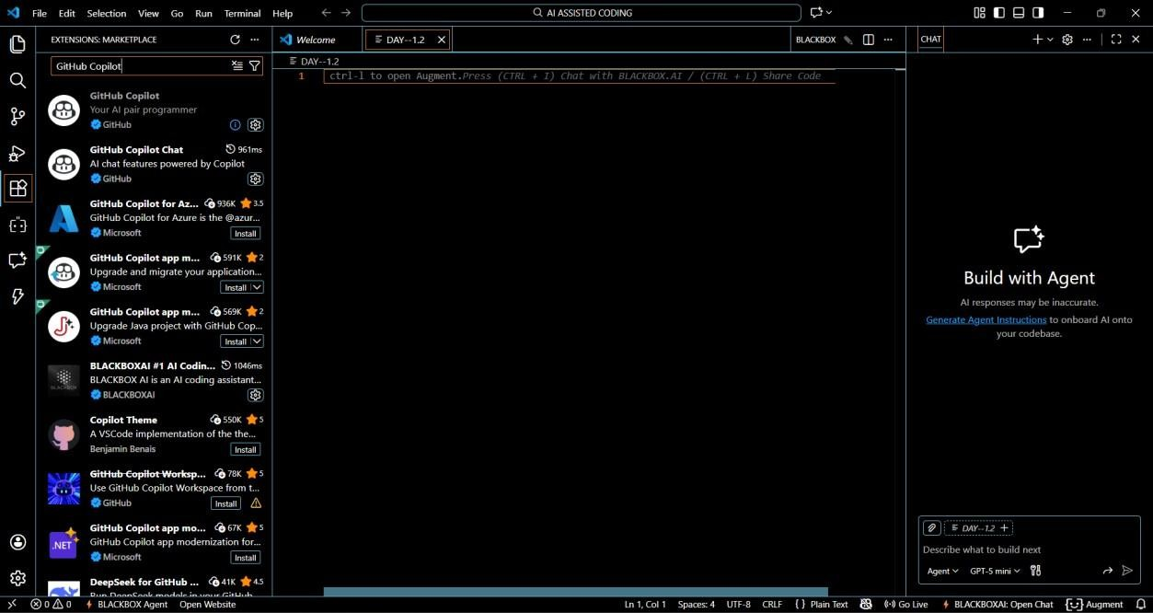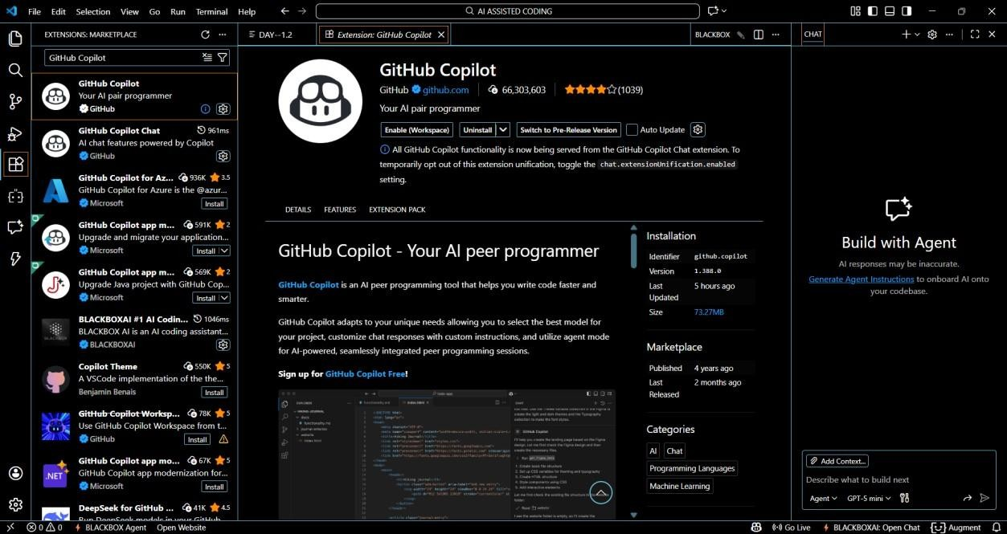
Explanation: GitHub Copilot was installed and configured in Visual
Studio Code by signing in with a GitHub account. This enables AI-based code suggestions directly inside the editor, helping developers write code faster and more efficiently.

Task 1: String Reversal Without Functions
Prompt:
# Write a Python program that accepts a string from the user
# Reverse the string using a loop
# Do not use any user-defined functions
# Print the reversed string
###CODE:
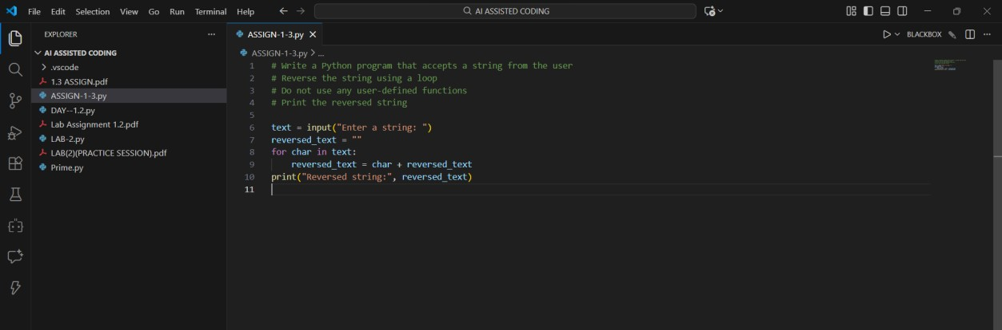
### OUTPUT:
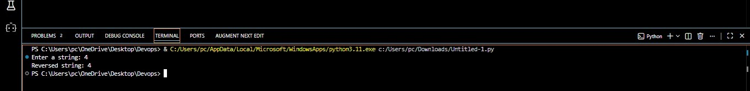
Explanation: In this task, GitHub Copilot generated Python code to reverse a string using a loop without defining any functions. The logic was written directly in the main program, demonstrating basic procedural programming.

Task 2: Code Optimization & Readability
Prompt:
# Simplify this string reversal code
# Remove unnecessary variables # Improve readability and efficiency ###CODE:
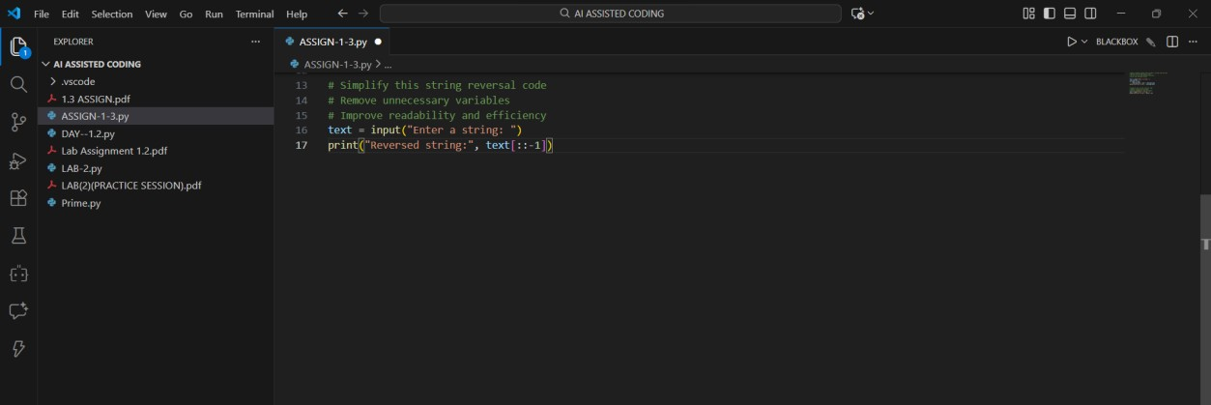
### OUTPUT:
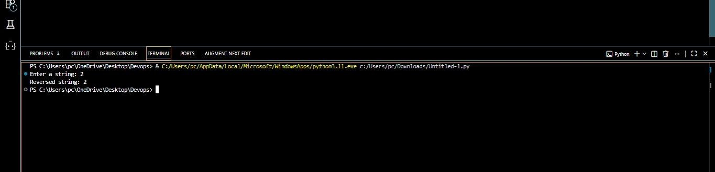
Explanation: The Copilot-generated code was optimized by simplifying the logic and removing unnecessary variables. The improved version produces the same output with better readability and reduced code complexity.

Task 3: String Reversal Using Functions
Prompt:
# Write a Python program using a function to reverse a string
# The function should return the reversed string
# Add meaningful comments ###CODE:
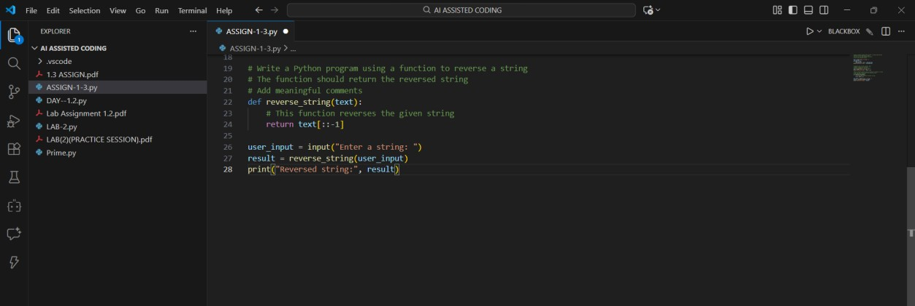
### OUTPUT:
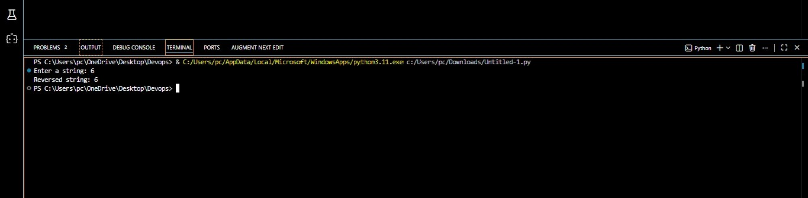
Explanation: GitHub Copilot was used to create a modular program using a user-defined function to reverse a string. This approach improves reusability, clarity, and makes the code easier to maintain.

Task 4: Procedural vs Modular Comparison
Step 1: Prompt:
# Compare string reversal programs with and without functions
# Discuss clarity, reusability, debugging, and scalability
Step 2: Answer (Analysis Output)
Feature | Without Function | With Function
Code clarity | Medium | High
Reusability | Low | High
Debugging | Difficult | Easy
Large applications | Not suitable | Suitable
Explanation: A comparison was made between function-based and nonfunction-based programs. The analysis shows that modular code is more reusable, easier to debug, and better suited for large-scale applications.

Task 5: Loop vs Built-in Reversal
Step 1: Loop-Based Prompt
# Write a Python program to reverse a string using a loop
# Do not use slicing or built-in methods ###CODE:
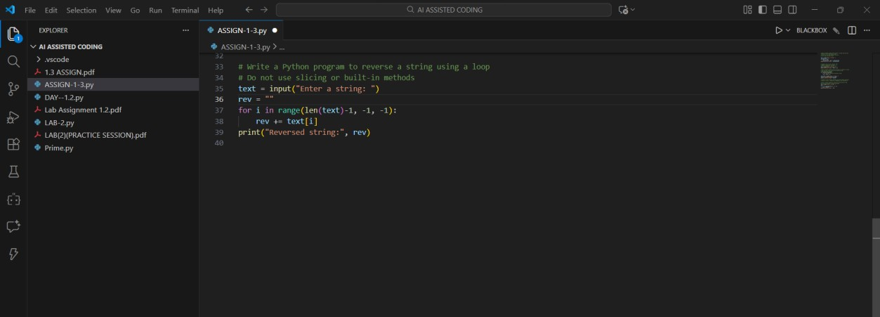
### OUTPUT:
Step 2: Built-in Prompt
# Write a Python program to reverse a string using slicing ###CODE:
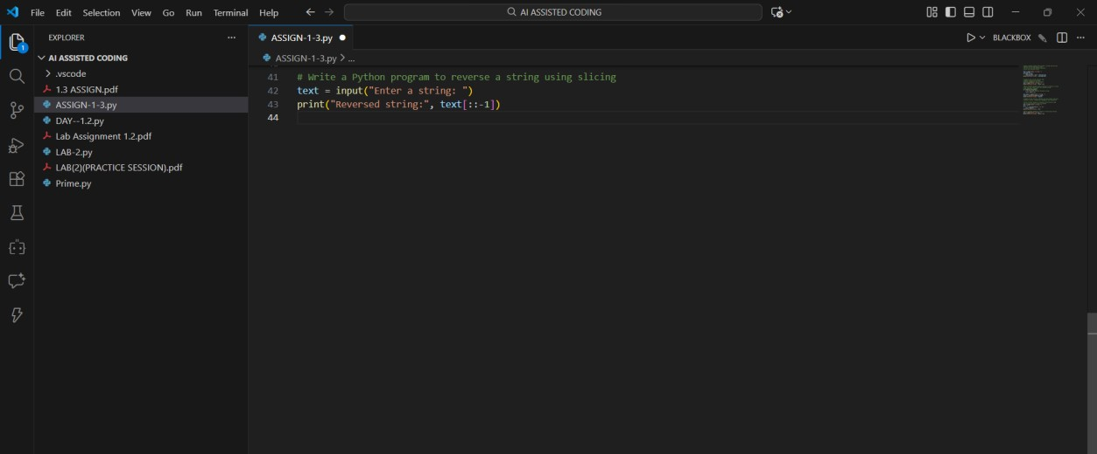
### OUTPUT:
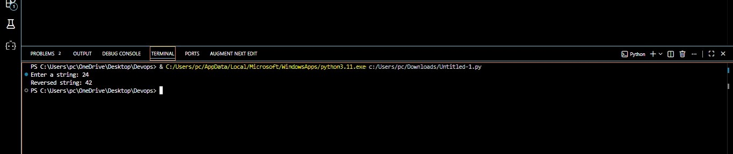
Explanation: Two different string reversal approaches were generated using Copilot: loop-based and built-in slicing. Both methods have the same time complexity, but the built-in approach is more concise and readable.

